**Ex 4 Virtualization**

**Date: 01.09.2020**

**Aim:**

To study and implement the installation of FreeDOS and overlay the emulator.

1. Install FreeDOS and overlay the QEMU emulator over the OS

2. Any emulator: open-source application over FreeDOS

**Description:**

**FreeDOS :**

DOS is a "disk operating system" created when personal computers ran from floppy disks. Even when computers supported hard drives, it was common in the 1980s and 1990s to switch frequently between the different drives. For example, you might make a backup copy of your most important files to a floppy disk.

FreeDOS is an old operating system, but it is new to many people. In 1994, several developers and I came together to create FreeDOS—a complete, free, DOS-compatible operating system you can use to play classic DOS games, run legacy business software, or develop embedded systems. Any program that works on MS-DOS should also run on FreeDOS.

**QEMU:**

QEMU is a generic and open source machine & userspace emulator and virtualizer.

What QEMU can do:

Emulate a complete machine without hardware virtualization

Emulate with Xen/KVM hypervisors

Provide userspace API virtualization

In computing, an emulator is a hardware or software that enables one computer system (called the host) to behave like another computer system (called the guest).

In 1963, when microcode was first used to speed up this simulation process, IBM engineers coined the term “emulator” to describe the concept. In the 2000s, it has become common to use the word “emulate” in the context of software. However, before 1980, “emulation” referred only to emulation with a hardware or microcode assist, while “simulation” referred to pure software emulation.

Purists continue to insist on this distinction, but currently, the term “emulation” often means the complete imitation of a machine executing binary code while “simulation” often refers to computer simulation, where a computer program is used to simulate an abstract model.

**VirtualBox:**

VirtualBox is a powerful x86 and AMD64/Intel64 virtualization product for enterprise as well as home use. Not only is VirtualBox an extremely feature-rich, high-performance product for enterprise customers, it is also the only professional solution that is freely available as Open Source Software under the terms of the GNU General Public License (GPL) version 2.

Presently, VirtualBox runs on Windows, Linux, Macintosh, and Solaris hosts and supports a large number of guest operating systems including but not limited to Windows (NT 4.0, 2000, XP, Server 2003, Vista, Windows 7, Windows 8, Windows 10), DOS/Windows 3.x, Linux (2.4, 2.6, 3.x and 4.x), Solaris and OpenSolaris, OS/2, and OpenBSD.

VirtualBox is being actively developed with frequent releases and has an ever-growing list of features, supported guest operating systems, and platforms it runs on. VirtualBox is a community effort backed by a dedicated company: everyone is encouraged to contribute while Oracle ensures the product always meets professional quality criteria.

**Exercise**

**1. Install FreeDOS and overlay the QEMU emulator over the OS**

**Step 1 :**

Installing Qemu

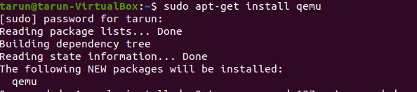

**Step 2 :**

Check version

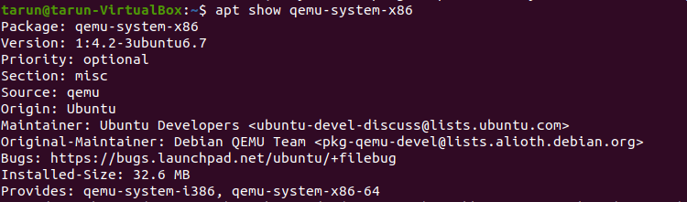

**Step 3 :**

Adding files and checking the status & move the downloaded file of FreeDOS for installing FreeDOS

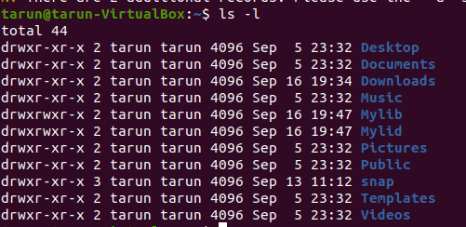

**2. Install any emulator: open-source application over FreeDOS**

**Step 1 :**

Installing VirtualBox & version

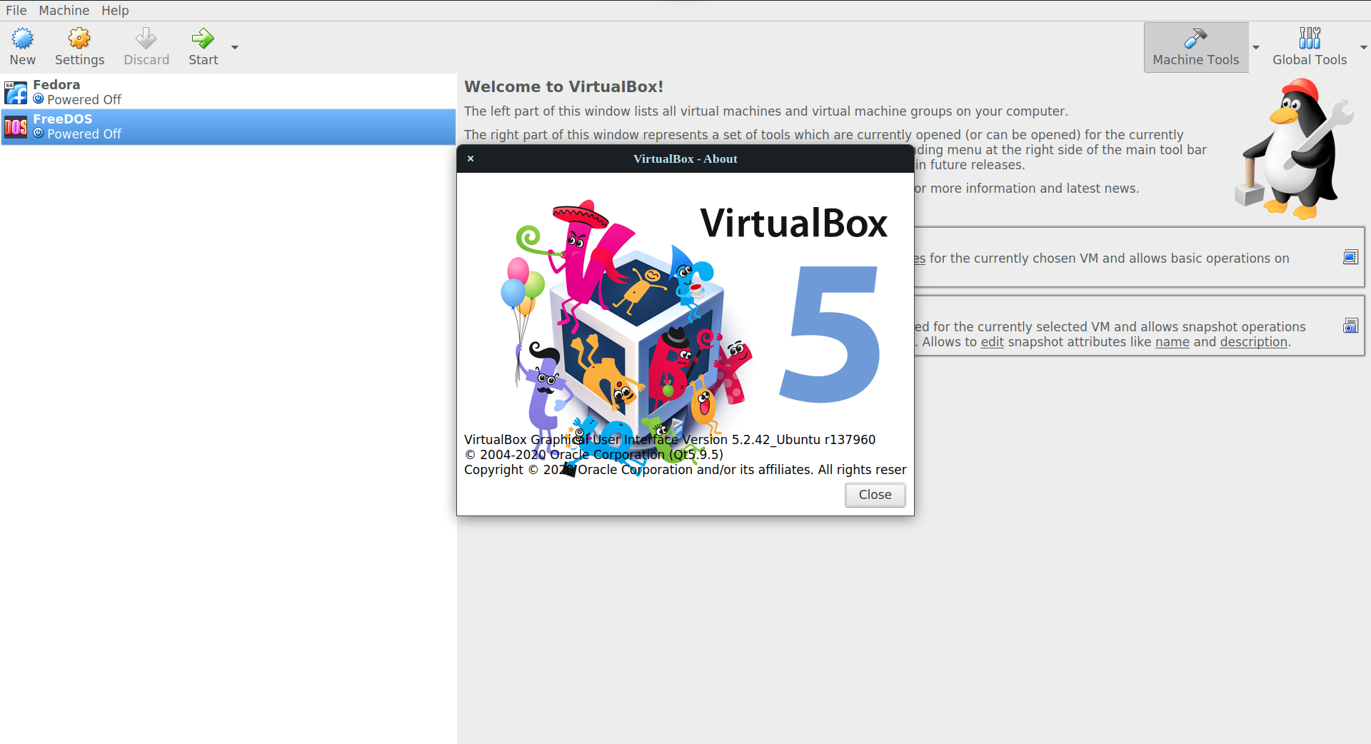

**Step 2 :**

Create a virtual machine, name it as FreeDOS, and select a memory size of 4MB

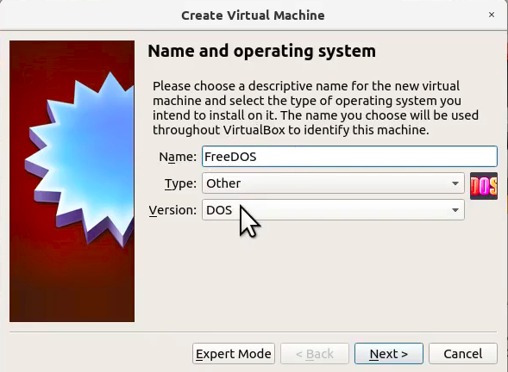

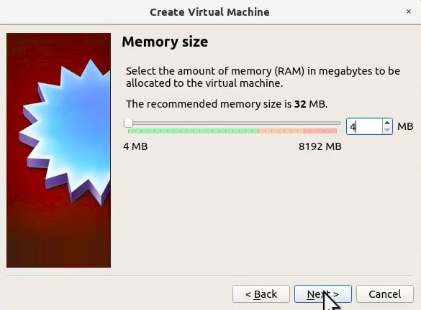

**Step 3 :**

Start your virtual machine, press the tab key to enter the command as raw, select the preferred language and reboot the machine

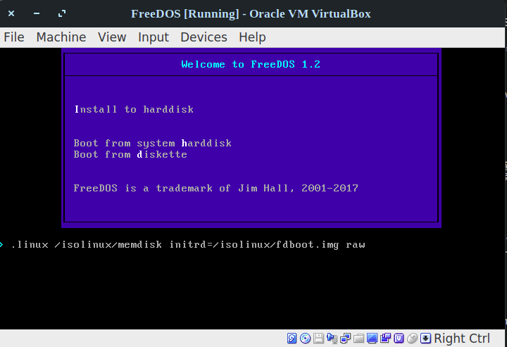

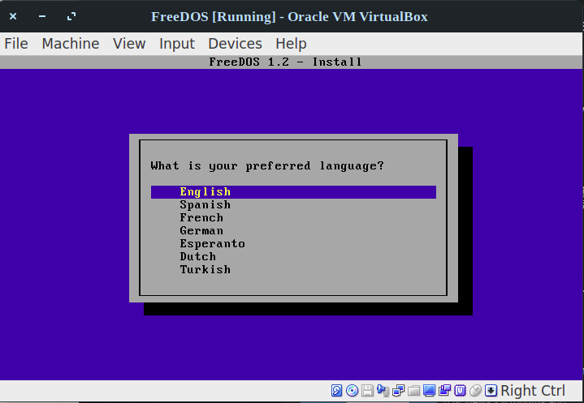

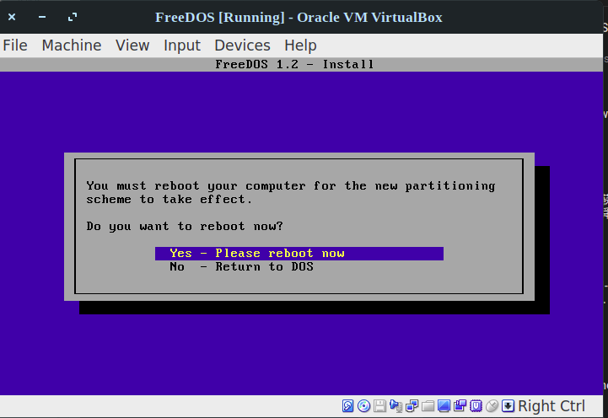

**Step 4 :**

Erase the C: and format to appear C, Press Full installation and reboot the machine

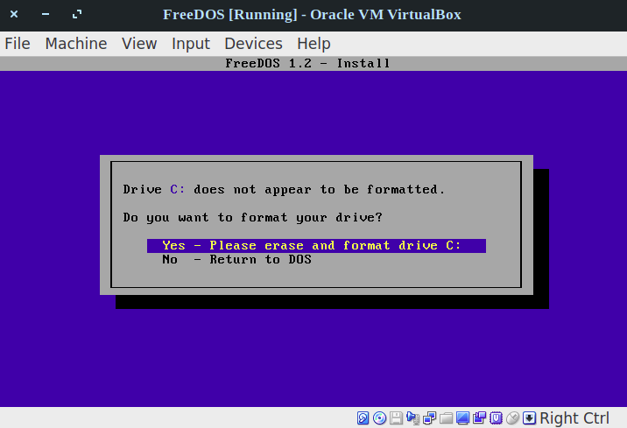

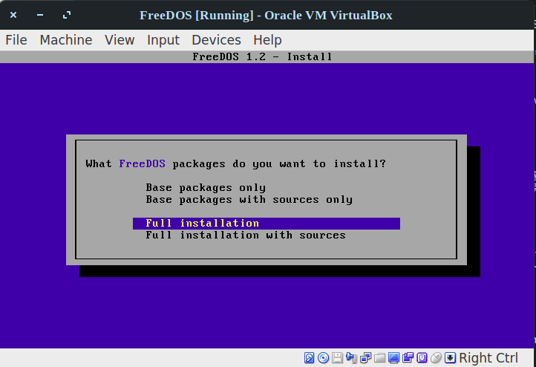

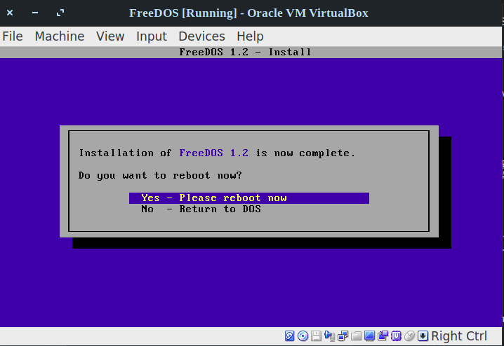

**Step 5 :**

Your FreeDOS is ready to use

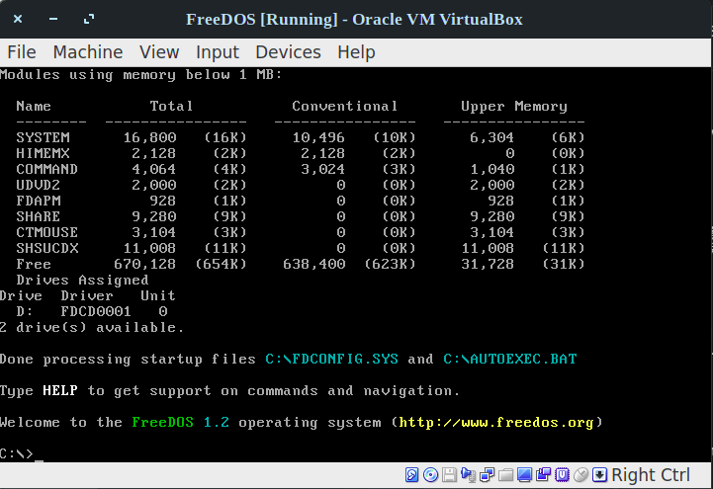

**Results:**

The study and implementation of the installation of FreeDOS and overlay of the emulator are studied and executed.

**Video link :** **https://youtu.be/Q0ompiWqhy4**